“LibroTrack: Bookstore and Stationery Shop Management System”



In Partial Fulfilment of the Requirements of the Courses:
IT112 – Advanced Database System & IT113 – Event Driven Programming

Ancog III, Saturnino
Ilajas, Ace Romel
Lenterna, Cleentson Dewey
Moleta, Idyll Claire
Orilla, Aljune

John Louis Mercaral, MIS
Courses Instructor

December 2025
Table of Contents
I. PROBLEM STATEMENT 1
II. LOGICAL DESIGN 2
Requirements Analysis 2
Entities: 2
Attributes: 2
Relationship & Cardinality: 4
Data Model (ER Diagram): 5
III. PHYSICAL DESIGN 7
SQL Queries: 7
API: 7
IV. Ecommerce: 8
Features: 8
Objectives: 8
Scope and Limitation: 9
Reference 10

- PROBLEM STATEMENT
Managing a bookstore and stationery shop in the digital age requires more than just traditional retail practices. Many businesses still rely on manual or semi-digital processes such as spreadsheet-based inventory tracking, separate online sales channels and unlinked customer databases. These fragmented methods are prone to human error, inefficiency and data inconsistency which hinder accurate monitoring of online sales and inventory. In the context of e-commerce stockouts and overselling are common problems when product availability is not updated in real-time leading to customer dissatisfaction and potential loss of revenue. Without a centralized and automated system store owners struggle to manage orders inventory and customer records efficiently reducing competitiveness in a rapidly growing online marketplace .
Another challenge arises from the limited integration of online sales payment processing and inventory management in existing e-commerce solutions for bookstores and stationery shops. Many shops use third-party platforms or separate tools for product listing order processing and reporting which makes the process fragmented and time-consuming. This lack of system integration often results in discrepancies between actual inventory and what is displayed on the website. Additionally manual consolidation of e-commerce sales reports with inventory records can delay decision-making and reduce operational efficiency. Research shows that integrated web-based management systems not only minimize errors but also streamline online retail operations making businesses more competitive in the digital economy .

LOGICAL DESIGN

Requirements Analysis

The bookstore and stationery shop currently face challenges in managing their sales inventory and customer transactions efficiently. The absence of a centralized automated system results in difficulties tracking product availability processing customer orders and managing supplier information. Manual processes often lead to human errors such as incorrect pricing inaccurate stock counts and delays in order fulfillment. Moreover the lack of real-time sales monitoring and analytics makes it difficult for management to make informed decisions regarding product restocking and marketing strategies. Based on the principles of database normalization, this study explores the requirements analysis for the LibroTrack E-commerce Bookstore and Stationery Shop Management System, identifying its entities attributes and cardinalities to ensure data consistency minimize redundancy and improve overall operational efficiency.

Entities:
- Users
- Products
- Suppliers
- Orders
- Order_Details
- Inventory_Log

Attributes:
1. Users
- User_ID (PK)
- Full_Name
- Email
- Username
- Password
- Role (Customer, Admin, Staff)
- Contact_Number
- Address

2. Products
- Product_ID (PK)
- Product_Name
- Category (Book, Stationery, Notebook, Pen, etc.)
- Description
- Author/Brand (for books/stationery)
- Price
- Stock_Quantity
- Supplier_ID (FK)

3. Suppliers
- Supplier_ID (PK)
- Supplier_Name
- Contact_Number
- Email
- Address

4. Orders
- Order_ID (PK)
- User_ID (FK – Customer)
- Order_Date
- Total_Amount
- Order_Status (Pending, Processing, Shipped, Completed, Cancelled)

5. Order_Details
- OrderDetail_ID (PK)
- Order_ID (FK)
- Product_ID (FK)
- Quantity
- Subtotal

6. Inventory_Log
- Log_ID (PK)
- Product_ID (FK)
- Date
- Change_Type (Stock In, Stock Out, Sale)
- Quantity_Changed
- Remarks

Relationship & Cardinality:
- Users → Orders: One user (customer) can place many orders (1:M).
- Orders → Order_Details: One order can contain many products (1:M).
- Products → Order_Details: One product can appear in many orders
(M:M through Order_Details).
- Suppliers → Products: One supplier can supply many products (1:M).
- Products → Inventory_Log: One product can have many inventory logs (1:M).

Data Model (ER Diagram):

- Crow’s Foot

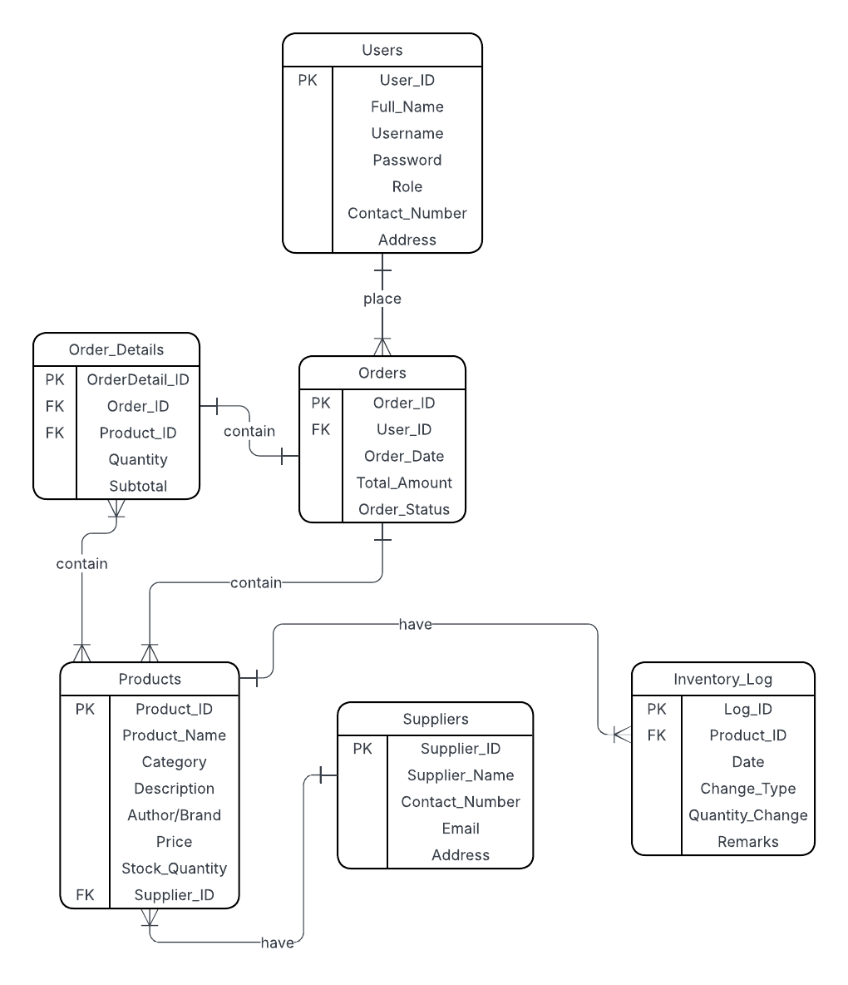

- Chen Notation

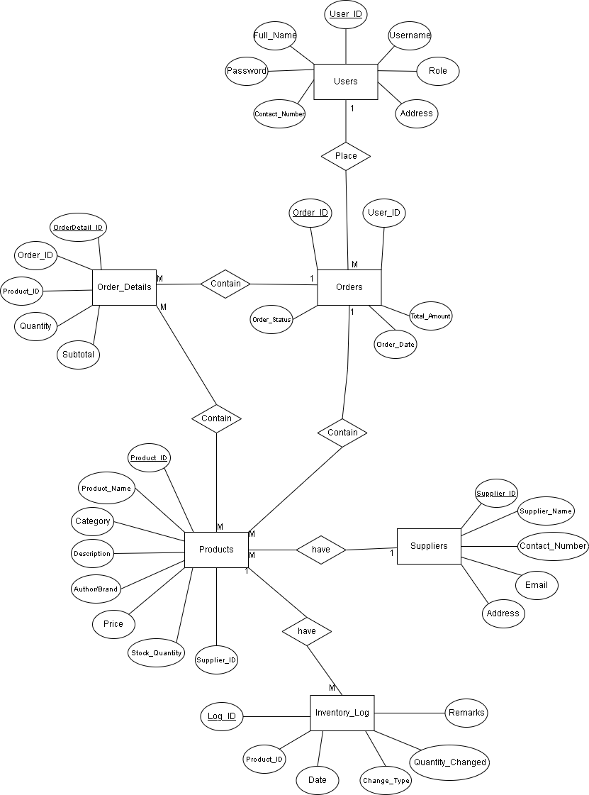

PHYSICAL DESIGN

SQL Queries:

Ecommerce:

Features:
- User Authentication – secure login and registration for customers and administrators.
- Product Catalog – online browsing of books and stationery items with search and filter options.
- Shopping Cart – customers can add items to cart.
- Inventory Management – stock levels automatically adjust when purchases are made.
- Supplier Management – manage supplier information for restocking purposes.
- Sales Reports – admin can view daily, weekly and monthly sales reports.
- Customer Management – stores customer details and order history.
- Responsive Design – accessible via desktop, tablet and mobile.

Objectives:
General Objective

- To design and develop a web-based e-commerce system for bookstores and stationery shops that enables online product browsing, purchasing, and inventory management.

Specific Objectives

- To create a web-based platform where customers can browse, search and purchase products online.
- To implement inventory management that updates stock levels in real-time after orders.
- To provide administrative tools for managing products, suppliers and sales reports.
- To ensure data security and protect customer information through authentication and encryption.

Scope and Limitation:
Scope

- The system allows customers to register, log in and shop online for books and stationery.
- Customers can search, filter and order products through a responsive web interface.
- Admin can manage products, inventory, suppliers and orders via a web dashboard.

Limitations

- The system does not include physical logistics/delivery services order delivery depends on third-party couriers.
- It does not include advanced recommendation engines (e.g. AI-based product suggestions).
- The system focuses on bookstore and stationery products only not other retail goods.
- The system requires a stable internet connection to access features since it is web-based.
- Customer support features such as live chat are not included unless integrated later.

Reference
[1] Das, S. (2021). Search engine optimization and marketing: A recipe for success in digital marketing. Chapman and Hall/CRC.
[2] Chen, W. H., Lin, Y. C., Bag, A., & Chen, C. L. (2023). Influence factors of small and medium-sized enterprises and micro-enterprises in the cross-border e-commerce platforms. Journal of Theoretical and Applied Electronic Commerce Research, 18(1), 416-440.

